**I-DEAL-LIFESTYLE**

**Summer Internship Report**

***Submitted by***

**DAMANPREET KAUR**

***in partial fulfillment for the award of the degree***

***of***

**BACHELOR OF TECHNOLOGY**

**IN**

**COMPUTER SCIENCE AND ENGINEERING**

**At**



**FACULTY OF ENGINEERING, DESIGN AND AUTOMATION**

**DEPARTMENT OF COMPUTER SCIENCE AND ENGINEERING**

**December 2022**

**CANDIDATE’S DECLARATION**

I hereby certify that the work, which is represented in the course by **Damanpreet kaur, GU-2021-4146** Partially fulfilled the requirement for the award of certificate in this course submitted in FEDA-CSE at GNA UNIVERSITY, Phagwara is an authentic record of my own work carried out during a period of 45-days summer internship.

**Signature of the Student**

**Name of Student: Damanpreet kaur**

**Registration No.:GU-2020-4146**

**ACKNOWLEDGEMENT**

I would like to place on record my deep sense of gratitude to Harish Chawla, O7 Solutions, Jalandhar. For his/her generous guidance, help and useful suggestions

I express my sincere gratitude to Dr. Anurag Sharma, HOD, Department of Computer Science and Engineering, GNA University, Phagwara, for his stimulating guidance, continuous encouragement and Supervision throughout the course of present work.

I am extremely thankful to Dr. Vikrant Sharma, Dean (FEDA-E) for providing me infrastructural Facilities to work in, without which this work would not have been possible.

**NAME OF STUDENT: Damanpreet kaur**

**ROLL NO.: GU-2020-4146**

**TRAINING COMPLETION CERTIFICATE**

**Abstract**

Interior design is the art and science of enhancing the interior of a building to achieve a healthier and more aesthetically pleasing environment for the people using the space. The growth of this sector and the fact the city that we are setting the shop up is growing in India. With little competition from qualified designers, we are confident we will get a strong market share in the first year. An interior designer is someone who plans, researches, coordinates and manages such enhancement projects. Interior design is a multifaceted profession that includes conceptual development, space planning, site inspections, programming, research, communicating with the stakeholders of a project, construction management, and execution of the design. The design business enjoys strong demand as people continue to buy or move into new homes and remodel old ones.

The interior design business is go out of your house kind of home business. While doing the business aspects inside the home, most of the sales will be done at the client’s home or office as you evaluate the space, match colour swatches to existing furniture and measure windows for draperies, etc. There have been countless books and magazines published for the sector. Both of the owner of this new design business have been trained and have worked in this sector for a number of years. These skills will play a big role in the success of the business.

**Company Profile**

**O7 Solutions**

O7 Solutions is a young IT consultancy, a 9001:2015 certified organisation with an expanded client base. They began quite recently, nonetheless, started ascending the most elevated stepping stone in the business, with their special mix of thoughts and arrangements, organised according to the prerequisite of business. They accept each business need and make sure that the entire cycle of the services they provide is simple for all organisations. They take care of the brands and the people with thoughts. They assist with specialised arrangements as well as with aiding raise a startup and organisations at their beginning phases, with their enhanced financial backup organisation and advisory services.

O7 Solutions bargain in ample services like Web Development, Mobile Application Development, Custom Software Development, Domain Name Registrations, Hosting Services, and Digital Marketing Services like Search Engine Optimization (SEO), Social Media Marketing (SMM), Pay Per Click (PPC), Email Marketing, Content Marketing & Search Engine Marketing (SEM), Graphic Designing, SMS Services, Voice Services etcetera. Their team of experts always provides rich customer experience by keeping their needs in mind and only then implements the operations required.

**APPS/ PRODUCTS DEVELOPED BY O7 SOLUTIONS**











**Email: enquiry@o7solutions.in, hr@o7solutions.in**



**www.o7solutions.in**

** Phone: +91-6284545231, 9592924601**

**Table of Contents**

|  |  |  |  |
| --- | --- | --- | --- |
| **CHAPTER NO.** | **TITLE** | **PAGE NO.** | **REMARKS** |
|  | Candidate’s Declaration | i |  |
|  | Acknowledgement | ii |  |
|  | Training completion certificate | iii |  |
|  | Abstract | iv |  |
|  | Company profile | v-vii |  |
| 1. | **INTRODUCTION**   * 1. Purpose   2. Scope and objectives |  |  |
| **2.** | **TECHNOLOGY TO BE USED**  2.1 Introduction to HTML  2.1.1 Features of HTML  2.2 Introduction to CSS  2.2.1 Features of CSS  2.3 Introduction to Bootstrap  2.3.1 Features of Bootstrap  2.4 Introduction to JavaScript  2.4.1 Features of JavaScript  2.5 Introduction to PHP  2.5.1 Features of PHP  2.6 Introduction to MYSQL  2.1.1 Features of MYSQL |  |  |
| **3.** | 3.1. Existing system  3.2. Proposed system |  |  |
| **4.** | **SYSTEM DEVELOPMENT PROCESS**  4.1. System analysis  4.2. Feasibility study |  |  |
| **5.** | **DESIGN**  5.1. Logical design  5.2. Module design  5.3. Data Flow Diagram  5.3.1. Level 0  5.3.2. Level 1 for admin  5.3.3. Level 1 for designer  5.3.4. Level 1 for user  5.4. Database design  5.5. ER Diagram |  |  |
| **6.** | **HARDWARE AND SOFTWARE SPECIFICATIONS**  6.1. Software requirements  6.2. Hardware requirements |  |  |
| **7.** | **SYSTEM IMPLEMENTATION AND TESTING**  7.1 Implementation  7.2 Testing |  |  |
| **8.** | **SNAPSHOTS** |  |  |
| **9.** | **CONCLUSION** |  |  |
| **10.** | **BIBLIOGRAPHY** |  |  |

**Chapter 1**

**Introduction**

* 1. **Purpose**

I-Deal-Lifestyle is one of the web-based projects using where study material of various technologies and languages are present. A program that prepares designers to manage the full-service of different kinds of designs. Interior design is about creating the most efficient layout to make the most of a room’s potential in terms of use and aesthetics while taking into account the characteristics of the space and the style desired. The main goal is to improve the effectiveness, accessibility, functionality and aesthetic appeal of an environment in a way that ensures the safe and optimal occupation and use of the interior space.

Interior design is the art and science of enhancing the interior of a building to achieve a healthier and more aesthetically pleasing environment for the people using the space. The growth of this sector and the fact the city that we are setting the shop up is growing in India. With little competition from qualified designers, we are confident we will get a strong market share in the first year. An interior designer is someone who plans, researches, coordinates and manages such enhancement projects. Interior design is a multifaceted profession that includes conceptual development, space planning, site inspections, programming, research, communicating with the stakeholders of a project, construction management, and execution of the design. The design business enjoys strong demand as people continue to buy or move into new homes and remodel old ones.

The interior design business is go out of your house kind of home business. While doing the business aspects inside the home, most of the sales will be done at the client’s home or office as you evaluate the space, match colour swatches to existing furniture and measure windows for draperies, etc. There have been countless books and magazines published for the sector. Both of the owner of this new design business have been trained and have worked in this sector for a number of years. These skills will play a big role in the success of the business.

This project contain three modules i.e., Admin, Designer, and User. In admin side, there is a particular stored mail id and password to login as an admin. An admin can add categories of different types with the images also edit and delete the categories. Admin can also view designers and user which are registered in it. In designer side, there is a register and login form then designer can add designs in different categories with complete description about it and also manages the designs as well as bookings done by users. In User side, there is a register and login form then user can view all the services provided to them and then users view the designers as well as select the designs to book according to their requirements. User can book the designs then designer decided that the design approved or not for completion the requirements of user. This show the basic structure and functionality of the project.

**1.2 Scope and objectives**

* + Sites visits and inspections.
  + Conceptual development.
  + Communication with stakeholders.
  + Planning of the space.
  + Execution of the design.
  + Freedom to show your creativity.

**Chapter 2**

**Technology to be used**

**2.1 Introduction To HTML**

HTML is a combination of Hypertext and Markup language. Hypertext defines the link between web pages. A markup language is used to define the text document within the tag which defines the structure of web pages. This language is used to annotate (make notes for the computer) text so that a machine can understand it and manipulate text accordingly. Most markup languages (e.g. HTML) are human-readable. The language uses tags to define what manipulation has to be done on the text.

**2.1.1. Features of HTML:**

* It is easy to learn and easy to use.
* It is platform-independent.
* Images, videos, and audio can be added to a web page.
* Hypertext can be added to the text.
* It is a markup language.

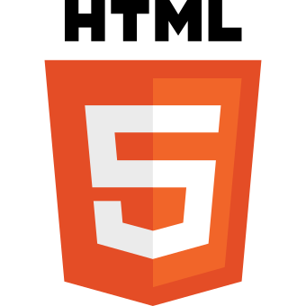

**2.2 Introduction To CSS**

**C**ascading **S**tyle **S**heets, fondly referred to as CSS, is a simple design language intended to simplify the process of making web pages presentable. CSS handles the look and feel part of a web page. Using CSS, you can control the color of the text, the style of fonts, the spacing between paragraphs, how columns are sized and laid out, what background images or colors are used, layout designs,variations in display for different devices and screen sizes as well as a variety of other effects. CSS is easy to learn and understand but it provides powerful control over the presentation of an **.**HTML document. Most commonly, CSS is combined with the markup languages HTML or XHTML.

**2.2.1.Features of CSS:**

* It is easy to maintain the website.
* It is use to control the web.
* It provide more attributes.
* Page speed is faster.
* Easy formatting Changes.
* Quicker development changes.
* Compatibility across devices.

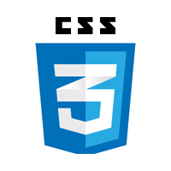

**2.3 Introduction To Bootstrap**

Bootstrap is a free and open-source tool collection for creating responsive websites and web applications. It is the most popular HTML, CSS, and JavaScript framework for developing responsive, mobile-first websites. It solves many problems which we had once, one of which is the cross-browser compatibility issue. Nowadays, the websites are perfect for all the browsers (IE, Firefox, and Chrome) and for all sizes of screens (Desktop, Tablets, Phablets, and Phones). All thanks to Bootstrap developers -Mark Otto and Jacob Thornton of Twitter, though it was later declared to be an open-source project. Bootstrap has evolved many versions and every time when we want to use this framework we can select the version which we want to use.

**2.3.1.Features of Bootstrap:**

* It is very easy and simple to use.
* It has great grid system.
* It contains Pre-styled components.
* It has responsive features.
* It is mobile-friendly.



**2.4 Introduction To JavaScript**

*Javascript is a cross platform*, single-threaded and *interpreted compiled* programming language which is also known as the scripting language for webpages. It is well-known for the development of web pages, and many non-browser environments also use it. JavaScript is a dynamically typed. JavaScript can be used for client side developments as well as server side developments. JavaScript is both an imperative and declarative type of language. JavaScript contains a standard library of objects, like Array, Date and Math, and a core set of language elements like operators, control structures, and statements.

**2.4.1. Features of JavaScript:**

* Light Weight Scripting language
* Dynamic Typing
* Object-oriented programming support
* Functional Style
* Platform Independent
* Prototype-based
* Interpreted Language
* Client-Side Validation
* More control in the browser



**2.5 Introduction To PHP**

PHP is a type of open-source general-purpose scripting language fit for server-side programming. It is a popular choice in web development in creating dynamic pages and applications. The acronym used to stand for ‘Personal Home Page’. But, now, PHP is known as Hypertext Preprocessor. The best part about using PHP is that it is extremely simple for a newcomer, but offers many advanced features for a professional programmer. Don't be afraid to read the long list of PHP's features. You can jump in, in a short time, and start writing simple scripts in a few hours.

**2.5.1. Features of PHP:**

* It is an Open source.
* Multi database syncing.
* High quality performance.
* Embedded.
* Better control quality.
* High security.



**2.6 Introduction To MYSQL**

MySQL is a powerful open-source database management system that is widely used for storing and organizing data. It is known for its fast performance, reliability, and ease of use, making it a popular choice for web applications, business data, and other types of data storage. MySQL is based on the Structured Query Language (SQL), a standard language for interacting with databases. With MySQL, you can create and modify databases, tables, and other database objects, as well as insert, query, and update data. You can also use MySQL to manage users and privileges, ensuring that only authorized users have access to your data.

**2.6.1 Features of MYSQL:**

* It is an open source.
* It is scalable and secure.
* It support for large databases.
* It is free to download.
* It has high flexibility.
* It is platform independent.



**Chapter 3**

**3.1. Existing system**

* Whenever any work is performed in our house then we find out the worker to perform that task there is lot of time to find out the worker and no information about that worker.
* Time wastage.
* Easily provides information about all the services.
* User can't take full advantage of all the services.
* Merchant can take work from our portal.

**3.2.Proposed System**

The aim of proposed system is to develop a system of improved facilities. The proposed system can overcome all the limitations of the existing system. The system provides proper security and reduces manual work. The existing system has several disadvantages and many more difficulties to work well. The proposed system tries to eliminate or reduce these difficulties up to some extent. The proposed system will help the user to reduce the workload and mental conflict. The proposed system helps the user to work user friendly and he can easily do his jobs without time lagging. All people can use credit cards, or debit cards or buy products for payment so that’s why we need to use online shopping not offline. This process actually helps to connect every people to the internet.

* **Expected Advantages of the Proposed System**

The system is very simple in design and to implement. The system requires very low system resources and the system will work in almost all configurations. It has got following features

**Chapter 4**

**System Development Process**

**4.1. System Analysis**

System analysis is a process of gathering and interpreting facts, diagnosing problems and the information to recommend improvements on the system. It is a problem solving activity that requires intensive communication between the system users and system developers. System analysis or study is an important phase of any system development process. The system is studied to the minutest detail and analyzed. The system analyst plays the role of the interrogator and dwells deep into the working of the present system. The system is viewed as a whole and the input to the system are identified. The outputs from the organizations are traced to the various processes. System analysis is concerned with becoming aware of the problem, identifying the relevant and decisional variables, analyzing and synthesizing the various factors and determining an optimal or at least a satisfactory solution or program of action.

A detailed study of the process must be made by various techniques like interviews, questionnaires etc. The data collected by these sources must be scrutinized to arrive to a conclusion. The conclusion is an understanding of how the system functions. This system is called the existing system. Now the existing system is subjected to close study and problem areas are identified. The designer now functions as a problem solver and tries to sort out the difficulties that the enterprise faces. The solutions are given as proposals. The proposal is then weighed with the existing system analytically and the best one is selected. The proposal is presented to the user for an endorsement by the user. The proposal is reviewed on user request and suitable changes are made. This is loop that ends as soon as the user is satisfied with proposal.

Preliminary study is the process of gathering and interpreting facts, using the information for further studies on the system. Preliminary study is problem solving activity that requires intensive communication between the system users and system developers. It does various feasibility studies.

**4.2. Feasibility Study**

Feasibility study is made to see if the project on completion will serve the purpose of the organization for the amount of work, effort and the time that spend on it. Feasibility study lets the developer foresee the future of the project and the usefulness. A feasibility study of a system proposal is according to its workability, which is the impact on the organization, ability to meet their user needs and effective use of resources. Thus when a new application is proposed it normally goes through a feasibility study before it is approved for development.

The document provide the feasibility of the project that is being designed and lists various areas that were considered very carefully during the feasibility study of this project such as Technical, Economic and Operational feasibilities.

**The following are its types:**

* **Technical Feasibility**

The system must be evaluated from the technical point of view first. The assessment of this feasibility must be based on an outline design of the system requirement in the terms of input, output, programs, and procedures. Having identified an outline system, the investigation must go on to suggest the type of equipment, the required method of developing the system, of running the system once it has been designed.

Technical issues raised during the investigation are:

* Does the existing technology sufficient for the suggested one?
* Can the system expand if developed?

The project should be developed such that the necessary functions and performance are achieved within the constraints. The project is developed within latest technology. Through the technology may become obsolete after some period of time, due to the fact that never version of same software supports older versions, the system may still be used. So there are minimal constraints involved with this project. The system has been developed using PHP the project is technically feasible for development.

* **Economic Feasibility**

The developing system must be justified by cost and benefit. Criteria to ensure that effort is concentrated on project, which will give best, return at the earliest. One of the factors, which affect the development of a new system, is the cost it would require.

The following are some of the important financial questions asked during preliminary investigation:

* The costs conduct a full system investigation.
* The cost of the hardware and software.
* The benefits in the form of reduced costs or fewer costly errors.

Since the system is developed as part of project work, there is no manual cost to spend for the proposed system. Also all the resources are already available, it give an indication of the system is economically possible for development.

* **Behavioral Feasibility**

This includes the following questions:

* Is there sufficient support for the users?
* Will the proposed system cause harm?

The project would be beneficial because it satisfies the objectives when developed and installed. All behavioral aspects are considered carefully and conclude that the project is behaviorally feasible.

**Chapter 5**

**Design**

Design is the first step into the development phase for any engineered product or system. Design is a creative process. A good design is the key to effective system. The term “design” is defined as “the process of applying various techniques and principles for the purpose of defining a process or a system in sufficient detail to permit its physical realization”. It may be defined as a process of applying various techniques and principles for the purpose of defining a device, a process or a system in sufficient detail to permit its physical realization. Software design sits at the technical kernel of the software engineering process and is applied regardless of the development paradigm that is used. The system design develops the architectural detail required to build a system or product. As in the case of any systematic approach, this software too has undergone the best possible design phase fine tuning all efficiency, performance and accuracy levels. The design phase is a transition from a user oriented document to a document to the programmers or database personnel. System design goes through two phases of development: Logical and Physical Design.

**5.1 Logical Design**

* The logical flow of a system and define the boundaries of a system. It includes the following steps:
* Reviews the current physical system – its data flows, file content, volumes, Frequencies etc.
* Prepares output specifications– that is, determines the format, content and Frequency of reports.
* Prepares input specifications– format, content, and most of the input functions.
* Prepares edit, security, and control specifications.
* Specifies the implementation plan.
* Prepares a logical design walk-through of the information flow, output, input, Controls and implementation plan.

**5.2 Module Design**

* Admin Module
* Designer Module
* User Module

**5.3 Data flow diagram**

**5.3.1 Level 0:**

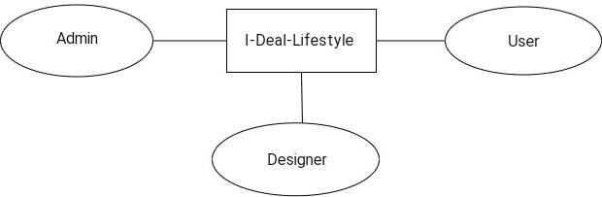

**5.3.2 Level 1 For Admin**

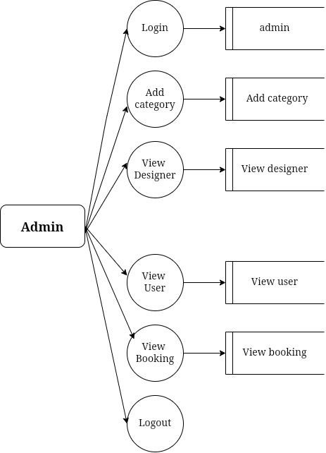

**5.3.3 Level 1 For Designer**

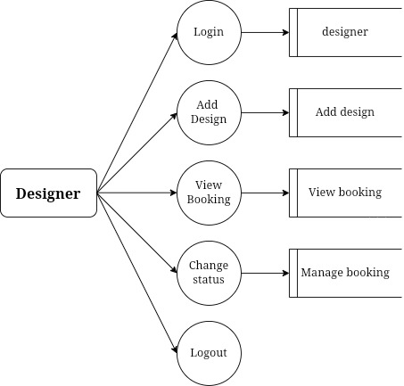

**5.3.4 Level 1 For User**

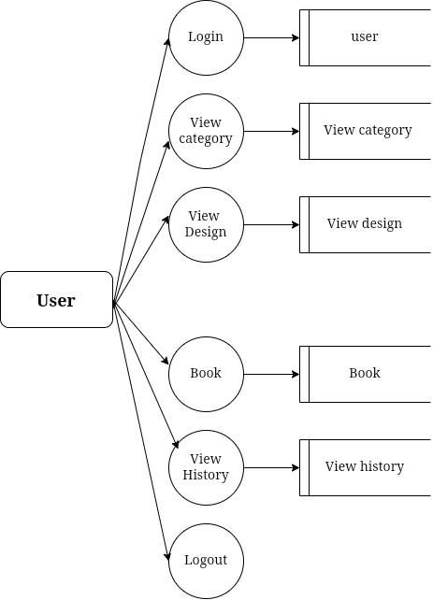

**5.4 Database Design**

A database is an organized mechanism that has the capability of storing information through which a user can retrieve stored information in an effective and efficient manner. The data is the purpose of any database and must be protected.

The database design is a two level process. In the first step, user requirements are gathered together and a database is designed which will meet these requirements as clearly as possible. This step is called Information Level Design and it is taken independent of any individual DBMS.

In the second step, this Information level design is transferred into a design for the specific DBMS that will be used to implement the system in question. This step is called Physical Level Design, concerned with the characteristics of the specific DBMS that will be used. A database design runs parallel with the system design. The organization of the data in the database is aimed to achieve the following two major objectives:

* Data Integrity
* Data independence

Normalization is the process of decomposing the attributes in an application, which results in a set of tables with very simple structure. The purpose of normalization is to make tables as simple as possible. Normalization is carried out in this system for the following reasons.

* + To structure the data so that there is no repetition of data , this helps in saving.
  + To permit simple retrieval of data in response to query and report request.
  + To simplify the maintenance of the data through updates, insertions, deletions.
  + To reduce the need to restructure or reorganize data which new application Requirements arise.

**Relational Database Management System (RDBMS)**

A relational model represents the database as a collection of relations. Each relation resembles a table of values or file of records. In formal relational model terminology, a row is called a tuple, a column header is called an attribute and the table is called a relation. A relational database consists of a collection of tables, each of which is assigned a unique name. A row in a tale represents a set of related values.

* **Relations, Domains & Attributes:**

A table is a relation. The rows in a table are called tulles. Tulle is an ordered set of n elements. Columns are referred to as attributes. Relationships have been set between every table in the database. This ensures both Referential and Entity Relationship Integrity. A domain D is a set of atomic values. A common method of specifying a domain is to specify a data type from which the data values forming the domain are drawn. It is also useful to specify a name for the domain to help in interpreting its values. Every value in a relation is atomic, that is not decomposable.

## Relationships:

Table relationships are established using Key. The two main keys of prime importance are Primary Key & Foreign Key. Entity Integrity and Referential Integrity Relationships can be established with these keys.

* Entity Integrity enforces that no Primary Key can have null values.
* Referential Integrity enforces that no Primary Key can have null values.
* Referential Integrity for each distinct Foreign Key value, there must exist a matching Primary Key value in the same domain. Other key are Super Key and Candidate Keys.
* Relationships have been set between every table in the database. This ensures both Referential and Entity Relationship Integrity.

**5.5.ER Diagram**

**Chapter 6**

**Software& Hardware Specifications**

**6.1 Software Requirements:-**

* Front-End Technologies: HTML, CSS, JavaScript
* Front-End CSS Framework: Bootstrap
* Web Server: XAMPP Server (latest version)
* Back-End Language: PHP (latest version)
* Database: MySQL (latest version)
* Browser: Mozilla Firefox, Google Chrome, or any modern web browser
* Operating System: Windows 10 (latest version) or any other compatible OS
* Integrated Development Environment (IDE): Notepad++, Visual Studio Code, or any preferred PHP IDE

**6.2 Hardware Requirements:-**

* Processor: Intel Core i3 or higher (e.g., Intel Core i5, Intel Core i7)
* RAM: 4 GB or higher
* Hard Disk: 100 GB or higher (SSD recommended for better performance)
* Internet Connection: Broadband or high-speed internet connection for testing and development purposes

**Chapter 7**

**System Implementation and Testing**

**7.1. Implementation**

Implementation is the status of the project when the theoretical designs turned into a working system. It is the process of converting a new revised system in to an operational one. It is the key stage in achieving a successful new system because usually it involves a lot of upheaval in the use department. It must therefore carefully plan and controlled so as to avoid chaos.

Apart from planning, the two major task of preparing for implementation are education and training of users and testing of system. Education of users should really have taken place much earlier in the project when they were being involved in the investigation and design work.

The user staff has been given necessary training for using the system. The training has made them to get acquainted with the system. The development any system results in success only when the system is implemented properly.

**7.2. Testing**

Testing is one of the major hurdles in the development of the system. Testing is the process of fining errors in the system. Only error-free website will be stable for a long time. There are different types of techniques for finding the bugs in website.

System testing is the major quality control measure during software development. A series of test cases are generated that is intended to demolish the software that has been built. Testing is a set activity that can be planned and conducted schematically. Testing begins at the module level and work towards the integration of entire computer based system.

Testing is a process of executing a program with the intention of finding an error. A good test case is one that has a higher probability of finding an undiscovered error. A successful test case is one that uncovers an undiscovered error. Nothing is complete without testing, as it the vital success of the system.

* **Testing Objectives**

There are several rules that can serve as testing objectives. They are

* Testing is a process of executing a program with the intent of finding an error.
* A good test case is one that has high probability of finding an undiscovered error.
* A successful test is one that uncovers an undiscovered error.

If testing is conducted successfully according to the objectives as stated above, it would uncover errors in the software. Generally by testing we are verifying the following three aspects.

* Testing for correctness
* Testing for implementation efficiency

**Chapter 8**

**Snapshots**

**Chapter 9**

**Conclusion**

I-Deal-Lifestyle is a new experience and has greatly impacted the lives of consumers in its short time of existence. It is expected to grow constantly in years to come with advancements in technology. Interior designing has made consumers more effective and efficient and has driven businesses to a new level, forcing many to make the necessary adjustments and changes to reach the new market of knowledgeable consumers. The results of this survey underscore the need for businesses to take the importance of lifestyle seriously. The survey conducted revealed a positive attitude and behavior toward the designing even by those consumers who still like traditional and modern designs.

These consumers are mostly of high age groups. Those consumer groups have time to spend in stores and shops of designing and value the offline shopping experience for social reasons, such as meeting with friends. These consumers appear to be more knowledgeable by gathering information online and then purchase it from traditional stores. Rapid growth of e-commerce has resulted in a E-transformation in the global retail infrastructure. Internet has emerged as a cost effective means of doing business. Despite being faced with numerous bottlenecks, Thanks to rising internet and higher incomes and more savvy population.

**Chapter 10**

**Bibliography**

* [**www.google.com**](http://www.google.com)
* [**www.financebusiness.com**](http://www.financebusiness.com)
* **www.w3school.com**
* [**www.scribd.com/pages?/emp**](http://www.scribd.com/pages?/emp)
* [**www.php.net**](http://www.php.net)
* **www.w3schools.in**
* **www.tutorialspoint.com**